H.T No
Regulations:
A17

Sreenidhi Institute of Science and Technology
(An Autonomous Institution)
Code No: 6A304 Date: 15-Feb-2024 (FN)

B.Tech II-Year I- Semester External Examination, Jan/Feb -2024 (Supplementary)
Circuits and Networks-II (EEE)

Time: 3 Hours Max.Marks:75
Note: a) No additional answer sheets will be provided.
b) All sub-parts of a question must be answered at one place only, otherwise it will not be valued.
c) Missing data can be assumed suitably.

Bloom's Cognitive Levels of Learning (BCLL)

Remember | L1 | Apply | L3 | Evaluate | L5
Understand | L2 | Analyze | L4 | Create | L6

Part - A Max.Marks:25

Answer all QUESTIONS.
 |  | BCLL | CO(s) | Marks
1 | The value of the current in phase R is I_{R} =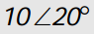A. Calculate the values of the three phase line currents. Assume an RYB phase sequence. | L4 | CO1 | [2M]
2 | What is transient analysis? Give the difference(s) between DC and AC transient analysis. | L2 | CO2 | [2M]
3 | What are the necessary conditions for a driving point function? | L2 | CO3 | [2M]
4 | Express Z parameters in terms of transmission parameters. | L1 | CO4 | [2M]
5 | Determine the cut-off frequency and the nominal impedance of the Low-pass filter shown below. | L5 | CO5 | [2M]
6 | Briefly discuss the properties of line spectra. | L2 | CO6 | [3M]
7 | Write the differences between balanced and unbalanced 3-phase circuits. | L1 | CO1 | [3M]
8 | Define short-circuit driving point admittance and transfer admittance parameters. | L1 | CO4 | [3M]
9 | Determine the Fourier transform of the general impulse | L5 | CO6 | [3M]
10 | List out the disadvantages of constant-k filter. | L1 | CO5 | [3M]

Part – B Max.Marks:50
ANSWER ANY FIVE QUESTIONS. EACH QUESTION CARRIES 10 MARKS.

 |  |  | BCLL | CO(s) | Marks
11. | a) | A 220V, 3-Phase voltage is applied to a balanced delta-connected 3-phase load of phase impedance (15+20j) Ω.  i) Find the phase current in each line.  ii) what is the power consumed per phase? (iii) what is the phasor sum of the three line currents? Why does it have this value? | L5 | CO1 | [5M]
 | b) | Explain the measurement of three phase active power and reactive power by using one-watt meter method. | L2 | CO1 | [5M]
12. | a) | A 50Hz sinusoidal voltage of maximum value of 400V is applied to a series circuit of resistance 10Ω and inductance of 0.1H. Find the expression for the value of the current at any instant after the voltage is applied, assuming that voltage is zero at the instant of application. Calculate its value 0.02 second after switching on. | L5 | CO2 | [5M]
 | b) | A D.C voltage of 100V is suddenly applied to a circuit consisting of a 100Ω resistor, a 0.1H inductor and a 100µF capacitor in series. The capacitor is initially uncharged. Obtain the expression which shows how the capacitor voltage varies with the time. | L4 | CO2 | [5M]
13. | a) | For the network shown below, determine the driving point impedance Z₁₁(s), the transfer impedance Z₂₁(s) and the voltage transfer ratio G₂₁(s).  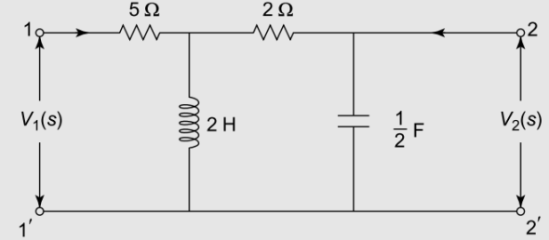 | L5 | CO3 | [5M]
 | b) | Draw the pole zero diagram for the given network and obtain the time domain response i(t).  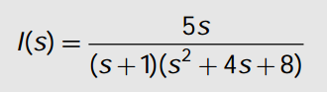 | L3 | CO3 | [5M]
14. | a) | Obtain ABCD parameters of the circuit shown below.  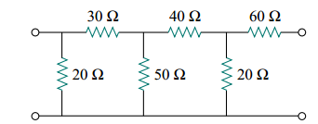 | L4 | CO4 | [5M]
 | b) | Obtain the Y-Parameters of the circuit shown below.  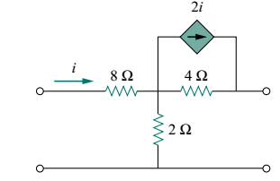 | L4 | CO4 | [5M]
15. | a) | Design an m-derived T section low pass filter having cut-off frequency of 1.5 kHz with a nominal impedance of 500Ω, and resonant frequency is 1600Hz. | L6 | CO5 | [5M]
 | b) | Explain the design procedure of constant ‘K’ high pass filter. | L2 | CO5 | [5M]
16. | a) | Find the exponential Fourier series of the triangular waveform shown below.  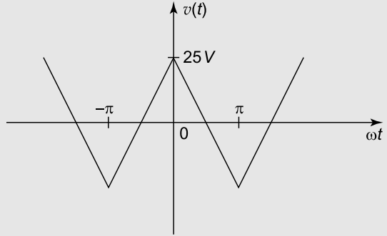 | L5 | CO6 | [5M]
 | b) | Determine the Fourier transform of the pulse shown below.  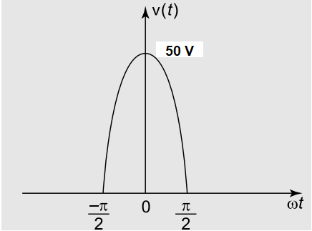 | L5 | CO6 | [5M]
17. | a) | In a balanced 3-phase, 3 wire system with Y connected load for which line voltage is 230V. and impedance of each phase is (6+j8) ohm. Find the line current and power absorbed by each phase. | L5 | CO1 | [4M]
 | b) | A series RL circuit with R=30Ω and L=15H has a constant voltage V=60V applied at t=0 as shown below. Determine the current i, voltage across resistor and the voltage across the inductor.  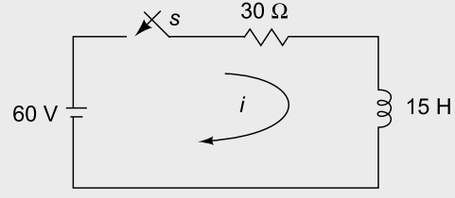 | L5 | CO2 | [3M]
 | c) | List any four properties of transfer function. | L1 | CO3 | [3M]
18. | a) | A two port network is described by V₁=2I₁+4V₂ and I₂=-3I₁+0.4 V₂. Find the impedance matrix. | L5 | CO4 | [4M]
 | b) | Briefly discuss about (i) Band pass filter (ii) Band elimination filter.  (iii) High pass filter. | L3 | CO5 | [3M]
 | c) | Determine the Fourier transform of the signal shown below.  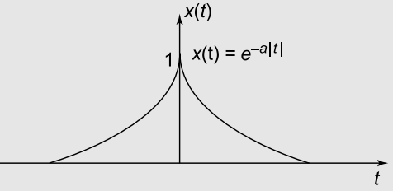 | L5 | CO6 | [3M]
-- 00 -- 00 –

